SPONSORSHIP OPPORTUNITIES

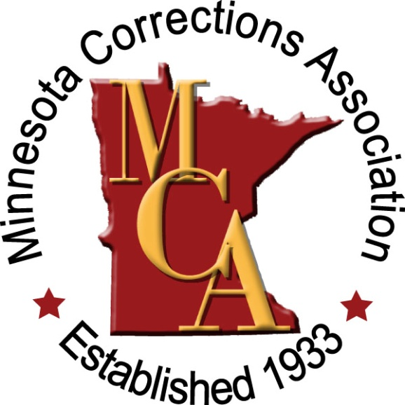

SPONSORSHIP OPPORTUNITIES

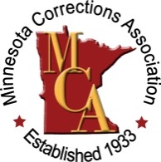
SPONSORSHIP OPPORTUNITIES
MCA continues to offer training options that are both relevant and interesting to corrections professionals across the state of Minnesota. Our Annual Fall Institute provides intensive two-day training for corrections professionals across broad range of specialties and levels of experience.

SPONSORSHIP OVERVIEW

Your involvement in MCA as a Sponsor is a tremendous opportunity to get your organization’s mission in front of our members. MCA encompasses hundreds of professionals representing all facets from the corrections field. We will be able to continue offering high quality programming throughout the year due to your generosity and support. Our goal is to provide a mutually beneficial partnership to you while our members participate in the educational and networking opportunities; creating lasting connections for you with these corrections professionals.

To discuss sponsorship opportunities, contact:

MCA Office
Debbie Beltz
651-462-8320
mca-mn@hotmail.com

Platinum Sponsorship: The most exclusive of our sponsorship packages, Platinum sponsorship offers organizations the best opportunity to leverage sales or programs, and reach important industry influencers attending the events of the MCA program year.

Gold Sponsorship: Our Gold sponsor package provides many of the same benefits as our Platinum package, and still allows year-round visibility for your organization at all of MCA’s major events.

Silver Sponsorship-Annual Fall Institute: Silver sponsorship of the Annual Fall Institute allows organizations to be in direct contact with Minnesota’s primary decision makers in the corrections industry at our biggest event of the program year.

Silver Sponsorship-Spring Workshop: This sponsorship allows organizations to be in direct contact with Minnesota’s primary decision makers in the corrections industry at our biggest event of the program year.

The Training & Education Committee goal is to promote education and training resources and opportunities to professionals in the field of corrections. Our committee identifies training needs that are specific to each region of the state, both community services and institutions. They seek input from members, regional representatives, MCA committees, and other corrections organizations. The training programs vary each year in terms of topics and locations in which a Spring Workshop is being held.

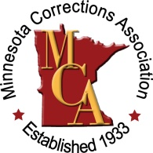

MCA MEMBERSHIP

SINCE 1933….

MCA is a 501(c) (3) nonprofit professional association that has served as a forum for corrections in Minnesota since 1933. We are an affiliate of both the American Probation and Parole Association and the American Corrections Association. Members from across the state represent all facets of the field, including probation, supervised release, community based programs, residential programs and correctional facilities.

Our Mission….
MCA MEMBERSHIP
600 plus members strong, MCA is open to anyone employed in a correctional agency or institution in Minnesota, public or private, whose primary function is that of providing services to individuals or groups under the care of their agency or institution. Persons who serve on boards of correctional agencies or institutions and citizens who have shown an interest in the advancement and development of the field of corrections may also become members.

To further discuss membership opportunities, please contact
Membership Committee Co-chairs:
Dayna Burmeister, 507-344-5281
dayna.burmeister@state.mn.us
Dan Kempf, 612-596-0489
dan.kempf@co.hennepin.mn.us

MCA’s mission is to promote the professional development of individuals working in all aspects of the corrections field and to promote ethical and just correctional practices.
ANNUAL SPONSOR
DETAILS & PRICING
MEMBERSHIP
ANNUAL SPONSORSHIP

Sponsorship Level Benefits
Sponsorship valid for 1 full year from date of enrollment

 | Silver Spring Workshop | Silver  Annual Fall Institute | Gold | Platinum
 | $800 | $800 | $1,000 | $1,500
Overall:
- Website visibility via company logo on MCA website home page | √ | √ | √ | √
- One year business membership | √ | √ | √ | √
- Additional individual memberships (number varies according to sponsorship level) | 2 | 2 | 5 | 10
- Company logo and website link on MCA Sponsor page | √ | √ | √ | √
- Company logo on MCA members only blast e-mails | √ | √ | √ | √
- Company logo on MCA blast e-mails to all MCA contacts |  |  | √ | √
- Company logo in each issue of the MCA newsletter, FORUM (six issue per year) |  |  |  | √
Annual Fall Institute:
- Complimentary exhibitor table |  | √ | √ | √
- Complimentary conference registration (number varies according to sponsorship level) |  | 2 | 2 | 2
- Reduced rate for additional conference registrations |  | 2 | 2 | 3
- Reduced rate meal packages-if applicable |  | √ | √ | √
- Logo identification on printed registration materials |  | √ | √ | √
- Signage at the Annual Fall Institute |  |  | √ | √
- Opportunity for one sheet insert in registration packet (supplied by the sponsor) |  |  |  | √
Spring Workshop:
- Complimentary exhibitor table | √ |  | √ | √
- Complimentary workshop registration (number varies according to sponsorship level) | 2 |  | 2 | 2
- Reduced rate for additional workshop registrations | 2 |  | 2 | 3
- Reduced rate meal packages-if applicable | √ |  | √ | √
- Logo identification on printed registration materials | √ |  | √ | √
- Signage at the workshop |  |  | √ | √
- Opportunity for one sheet insert in registration packet (supplied by the sponsor) |  |  |  | √

Optional Annual Fall Institute Sponsorship Opportunities
MCA offers other sponsorship opportunities at the Annual Fall Institute for current sponsors to enhance their sponsorship packages or for organizations with limited budgets who still want to gain exposure at our biggest event of the year.

COST: varies
Contact the MCA Office

Optional Sponsorship Opportunities

PRICING & DETAILS
Exclusive sponsorship opportunities available:

- Keynote Speaker Sponsor (Exclusive sponsorship opportunity)

- Awards Reception (Currently being sponsored)

- Past Presidents Breakfast (Currently being sponsored)

- Lanyard/Registration Portfolio Sponsor (Exclusive sponsorship opportunity)

- Break Sponsor (Limited opportunities available)

- Custom Package: Contact the MCA office to develop your own sponsor package

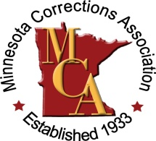
MCA SPONSOR AGREEMENT
AGREEMENT FORM

Instructions: Save this form to your computer, complete electronically, and remit it to the MCA office with payment if paying by check. If you wish to pay by credit card, you may submit your sponsorship on the MCA website
www.mn-ca.org.

Company Information (All fields are required.)
Organization

Name of contact person

Title of contact person

Address

City | State | ZIP
E-Mail

Phone

company website address (used for link access with logo (if applies to sponsorship level)

PREFERRED Company Representative
Information is same as above.
Organization

Name of contact person

Title of contact person

Address

City | State | ZIP
E-Mail

Phone

Payment Options
amout enclosed
$

I have enclosed a check (payable to MCA).

MCA SPONSORSHIP PACKAGES
Please check the sponsorship package that interests you:

ANNUAL SPONSORSHIP
Platinum Sponsor - $1,500
Gold Sponsor – $1,000
Silver Sponsor Fall Institute – $800
Silver Sponsor Spring Workshop – $800
Optional Sponsorship Opportunities – contact
MCA Office

SPONSORSHIP TERMS
DEADLINES: Sponsorship valid for 1 full year from date of enrollment. Submit application as soon as possible as exclusive sponsorship opportunities fill quickly.
COMPLIMENTARY ATTENDEES: If your sponsorship package includes complimentary conference session attendance, , you will be contacted for details. Some meal packages may not be included in sponsorship registrations (will be determined per specific event).

LOGO VISIBILITY/COMPANY LINK: Your Company’s logo will be used in marketing materials including: program, signage,
e-mails, and on the website according to sponsorship level. Please provide your company’s logo to the MCA office. You may provide both color and grayscale versions. Transmission by
e-mail is preferred.

Signature
I agree to abide by the rules and considerations detailed in this agreement.
Signature | Date
NOTE: You may embed a scanned signature or simply type your name in the signature block above. Returning this document to the MCA office with your name in the signature block constitutes an officially signed proposal.

Return completed form with payment to the MCA office listed below or return to your MCA representative assisting you with sponsorship:

P.O. Box 261
Wyoming, MN 55092
Phone: 651-462-8320
Fax: 651-717-6137
mca-mn@hotmail.com

Gold
Overall
- Web site visibility via company logo on MCA web site home page. (value $500)
- One-year business membership includes two representatives (value $100); plus additional three individual memberships (value $105)
- Company logo on MCA blast e-mails to all members (value $250)

Annual Fall Institute
- Exhibitor table at Fall Institute including conference session admittance for two (estimate value $600)
- Reduced rate meal packages (if applicable) (estimate value varies)
- Logo identification on e-mailed and printed registration materials (value $250)
- Company logo and web site link on MCA web site in conference registration details (value $150)
- Signage at the Annual Fall Institute (value $100)

training & education program
- Exhibitor table at Training & Education Spring Workshop including conference session admittance for two (estimate value $300)
- Reduced rate meal package (if applicable) (estimate value varies)
- Logo identification on e-mailed and printed registration materials (value $250)
- Company logo and web site link on MCA web site in workshop registration details (value $150)

